STUDENT & FAMILY INFORMATION GUIDE
2023/2024 Academic Year
Parkway West High School
Learning Network 13
4725 Fairmount Avenue Philadelphia, Pennsylvania 19139 T: 215.400.7710
F: 215.400.7711 https://parkwaywest.philasd.org
William J. Brown
Principal
Derrick Tate
Assistant Principal Principal
Preparing Tomorrow’s Educators

PARKWAY WEST HIGH SCHOOL
William J. Brown M.Ed., Principal
Derrick Tate M.Ed., Assistant Principal
Dear Students and Families:
The administration and staff of Parkway West High School (PWHS) welcomes you to a new academic year. It is our pleasure to extend greetings to our returning students and families and to extend a warm and hearty welcome to all our new students and families. We are indeed proud to have you as a part of the Parkway West family!
PWHS’ commitment to our students and families is one that remains unchanged. We do our best to ensure that our students’ time here is among the best of their PK-12 educational experience while, of course, working with them to build a strong foundation for success in college or career and life. As our slogan states, we are “Preparing Tomorrow’s Educators” and we thank you, the families, for the encouragement and support you have given us in this endeavor, as well as to keep all our students focused on the “ABCs of high school”:
- A – Attendance – Our goal is for students to have 95% or better attendance; therefore, students are expected not to miss more than nine (9) school days this year.
- B–Behavior–Our goal is for students to have zero (0) out-of-school suspensions; in view of this, students are expected to observe and adhere to the Student Code of Conduct in, on the way to and home from school, and at any school district-sponsored activities and to participate in any alternatives to suspension assigned by the school when their behavior warrants such a disciplinary intervention.
- C – Course Completion/Credit Attainment – Our goal is students to earn all eight (8) credits they are rostered for this year; accordingly, students are expected to complete all in and out-of-class assignments, read and study by themselves or with others, and to participate in after-school tutoring as required.
We believe that education is a joint responsibility of the home and school and that it is important for these units to maintain good communication and to work cooperatively and collaboratively in support of student success. To that end, we have prepared and are providing you with our Student & Family Information Guide so that you can be aware of our school’s current policies, procedures, expectations, standards, and guidelines affecting our students and families. It is our hope that you will take the time to review and discuss them as they support us in creating an authentic, transformational, and liberating educational experience for all our students.
Thank you in advance for your continued support. Best to all for a productive academic year! In Service to Children and Families,
William J. Brown
Principal
Derrick Tate
Assistant Principal
GENERAL SCHOOL AND SCHOOL DISTRICT INFORMATION
Parkway West High School
4725 Fairmount Avenue Philadelphia, PA 19139
T: 215.400.7710 | F: 215.400.7711 https://parkwaywest.philasd.org/
School Hours: 7:30 am to 2:34 pm
Main Office Hours: 7:30 am to 2:34 pm

Teacher Leader
Richard L. Daniels
Dean of Students
William Cohen
Roster Chairman
Paul Szeliga
Athletic Director
Brian Beaton
Office Manager
Beverly Brooks
English and Social Studies
Teachers
William Cohen
Michael Roe
James Santore
Mathematics Teachers
Evren Çakır
Fekade Wajy
Science Teachers
Evren Cakir
Ashley Figaniak
Paul Szeliga
World Language Teacher
Jan Cohen

Career and Technical Education (CTE) Teachers Myra Evans
Yenda Hall
Kish Taylor
Physical Education/Health Teacher
Brian Beaton
Art Teacher

Learning Support Teacher
Joseph Pasquarello
Earl Morgan
Sarah Moyer
Autistic Support Teachers
Christine Nalepka
Danesha Simmonds
English Language Development Teacher
Deena Franklin
School Counselors
Vanessa Drago
School Nurse
Dominique Sadler
School Psychologist
Amanda Breuing
School Speech and Language Pathologist
Josette Pacharis
Student Climate Staff
Karon Phillips
Shafi Tinsley
School Safety Officer
Denisha Lawrence
Special Education Assistants
Tonja Johnson
Yvonnie Johnson
Building Engineer
Manuel Eaddy
Custodial Assistant
Rachel James
General Cleaners
Joy Brown
Daniel Richards
Davin Dick
Joseph Pownall
Senior Food Service Workers
Charmaine Barfield
Ronnisha Bradley
Food Service Utility Worker
Terrese Thomas
Food Service Assistants
Tanya Anderson
Tashia Peel, Harriette Taylor

Distinguished by an educational philosophy and approach to learning that differed from that of the “traditional” education of the day in the time in which the program was established, the Parkway Program was a pioneer in alternative education in the United States.
On loan to the Board of Education from Temple University and assigned as the executive assistant for the Honorable Richardson Dilworth, board president and former mayor of the City of Philadelphia, the Parkway Program was the brainchild of Clifford Brenner who developed the concept for the program in 1969. As Mr. Brenner envisioned it, the Parkway Program would bring together adolescent learners from various neighborhoods and communities in Philadelphia, providing them with educational opportunities that would expose them to the resources of the public and private institutions along the Benjamin Franklin Parkway in Center City while also allowing them to earn the credits required for high school graduation. At the same time, the creation of the Parkway Program, which eventually became known as the “School Without Walls,” also allowed school district and city officials to solve a problem plaguing the city in the late 1960s—overcrowded high schools—and highlighted an important fact: the community as a whole should and must be a partner in the learning process.
Nationally acclaimed for its success with the young people it served, the Parkway Program grew leaps and bounds over a twenty-year period. Overseen by one administrator, the program expanded to multiple sites, known as “Units” across the city: the homebase for the Alpha, Beta, and Zeta Units was in Center City; the Delta Unit’s homebases were in Spring Garden and Northwest Philadelphia; and, the homebase for the Gamma Unit was in West Philadelphia.
As time went on, the members of the Board of Education changed as did the superintendent of schools, budget priorities shifted, and both the national standards movement and push to standardize the curriculum across the city took center stage. The changes, individually and collectively, had a negative impact on the Parkway Program as the number of sites were reduced and the concept of the “School Without Walls” effectively ended. In 2003, the Parkway Program officially disbanded as a part of the citywide transition to smaller high schools with each of the three remaining sites set to become their own independent high school. Parkway Center City did so that year and Parkway Northwest and Parkway Gamma did so the year after. To assure consistency in geographic naming conventions, in 2005, Parkway Gamma became Parkway West.
Located in the former Mayer Sulzberger School Building at 48th and Fairmount, which is located in the Mill Creek neighborhood in close proximity to University City – home to Drexel University and the University of Pennsylvania – today, Parkway West is a magnet (special admission) high school serving students from throughout the city. In 2004, the School District of Philadelphia in partnership with Philadelphia Academies, Inc. implemented an Urban Education Academy. Through this program, students explore key topics in education, including the history and philosophy of education, educational law, advocacy, and family involvement and community engagement, bringing the field of education into sharper focus. Additionally, students are introduced to career-specific areas of study that include child development, developmentally appropriate practices, inclusion of children with special needs, structure and organization of early childhood education centers and school-aged programs, and classroom management. By their senior year, students participate in and successfully complete several internships where they can observe mentor teachers, learn best practices for early childhood educators, and plan and deliver lessons to children from birth to age nine. Eligible students earn college credit for advanced placement and dual enrollment courses.
Our Mascot
The historical mascot for the Parkway Program is the Hoya.
While each of the three “Units” of the Parkway Program have now been long-standing independent high schools, each with their own distinct focus, the one only other thing that they retain in common besides the Parkway name is their—our—mascot.
We are the Parkway West High School Hoyas! HoyaPride!
5
Our Vision
A school in which administrators, staff, students, and partners collaborate to inspire and prepare a new generation of leaders.
A learning community designed to support creative, innovative, and committed students willing to consider a career in education.
Our Mission
The mission of Parkway West High School is to provide our students with a safe and nurturing learning environment thereby ensuring that all students achieve to their maximum academic and social potential and become productive citizens and lifelong learners. This will be achieved through a collegial bond among administration and staff, proficient teaching and learning, and collaboration with our families and community partners.
Our Beliefs
- A safe and nurturing environment is essential for student learning.
- Learning transpires at different rates and in different ways.
- Graduation is achievable in four years with students performing at either the advanced or proficient level across the curriculum.
- The opportunity to explore varied careers and learn by performing service provides knowledge and skills that are necessary for life-long learning.
- Preparing students to become responsible citizens is the shared responsibility of the school, student, parents/guardians, and community.
- Appreciation of religious and ethnic differences, culture, race, and gender is essential in today’s society.
- Every student has inherent worth and will have the opportunity to reach their personal goals.

2023-2024 Academic Calendar

August 2023 | 0 Student Days; 3 Staff Days
- 29th: Staff Professional Development or Reorganization (Varies by School)
- 30th- 31st: Staff Professional Development
September 2023 | 18 Student Days; 19 Staff Days
- 1st: Staff Professional Development or Reorganization (Varies by School)
- 4th: Labor Day; Schools closed for students and staff; Administrative offices closed
- 5th: First day of school for students
- 5th-11th: Kindergarten interview days (Three Hour early dismissal K only)
- 25th: Yom Kippur; Schools closed for students and staff; Administrative offices closed
- 29th: Staff Professional Development (Half Day); Three Hour Early Dismissal for Students
Additional Important Dates:
16th-17th: Rosh Hashanah (Weekend)
October 2023 | 21 Student Days; 22 Staff Days
- 27th: Staff Professional Development (Full Day); School closed for students
Additional Important Dates:
9th: Indigenous Peoples’ Day of Learning (In-school day)
November 2023 | 18 Student Days; 19 Staff Days
- 7th: Election Day; Schools closed for students and staff
- 22nd: 3-hour Early Dismissal for students and staff
- 23rd-24th: Thanksgiving Recess; School closed for students and staff; Administrative offices closed
- 27th: Term 1 Report Card Conferences (Full Day); School closed for students
Additional Important Dates:
5th: Daylight Saving Time ends
11th: Veterans Day
12th: Diwali
December 2023 | 16 Student Days; 16 Staff Days
- 15th: Staff Professional Development (Half Day); Three Hour Early Dismissal for Students
- 25th: Christmas Day; School closed for students and staff; Administrative offices closed
- 26th-29th: Winter Recess; School closed for students and staff; Administrative offices closed
January 2024 | 20 Student Days; 21 Staff Days
- 1st: New Year’s Day; School closed for students and staff; Administrative offices closed
- 2nd: Staff Professional Development (Full Day); School closed for students
- 15th: Dr. Martin Luther King Jr Day; School closed for students and staff; Administrative offices closed
Additional Important Dates:
3rd-17th: Keystone Testing Window
6th: Three Kings Day
February 2024 | 20 Student Days; 20 Staff Days
- 1st, 2nd: 2nd Term Report Card Conferences (Half Day); Three Hour Early Dismissal for Students
- 9th: Staff Professional Development (Half Day); Three Hour Early Dismissal for Students
- 19th: Presidents’ Day; School closed for students and staff; Administrative offices closed
Additional Important Dates:
10th: Lunar New Year (weekend)
March 2024 | 16 Student Days; 16 Staff Days
- 8th: Staff Professional Development (Half Day); Three Hour Early Dismissal for Students
- 25th-28th: Spring Recess; Schools closed for students and staff
- 29th: Good Friday; School closed for students and staff; Administrative offices closed
Additional Important Dates:
10th: Daylight Saving Time starts
11th: Ramadan begins
April 2024 | 20 Student Days; 20 Staff Days
- 4th, 5th: Report Card Conferences (Half Day); Three Hour Early Dismissal for Students
- 23rd: Election Day; School closed for students and staff (tentative)
- 10th: Eid al-Fitr; School closed for students and staff; Administrative offices closed
Additional Important Dates:
8th: Ramadan ends 22nd: PSSA testing window begins
May 2024 | 22 Student Days; 22 Staff Days
- 10th: Staff Professional Development (Half Day); Three Hour Early Dismissal for Students
- 27th: Memorial Day; School closed for students and staff; Administrative offices closed
Additional Important Dates:
3rd: PSSA testing window ends
13th- 24th: Keystone testing window
June 2024 | 10 Student Days; 10 Staff Days
- 13th: Staff Professional Development (Half Day); Three Hour Early Dismissal for Students
- 14th: Last Day of School for students and staff; Three Hour Early Dismissal for Students, Full day for Staff
- 17th: Eid al-Adha; Administrative offices closed
- 19th: Juneteenth; Administrative offices closed
Additional Important Dates:
12th-14th: Graduation window
July 2024
- 4th: Independence Day; School closed for students and staff; Administrative offices closed
August 2024
- 20th: Reorganization
- 21st, 22nd, 23rd: Staff Professional Development
- 26th: First day of school for students
- 26th-30th: Kindergarten interview day; Three Hour Early Dismissal (K only)
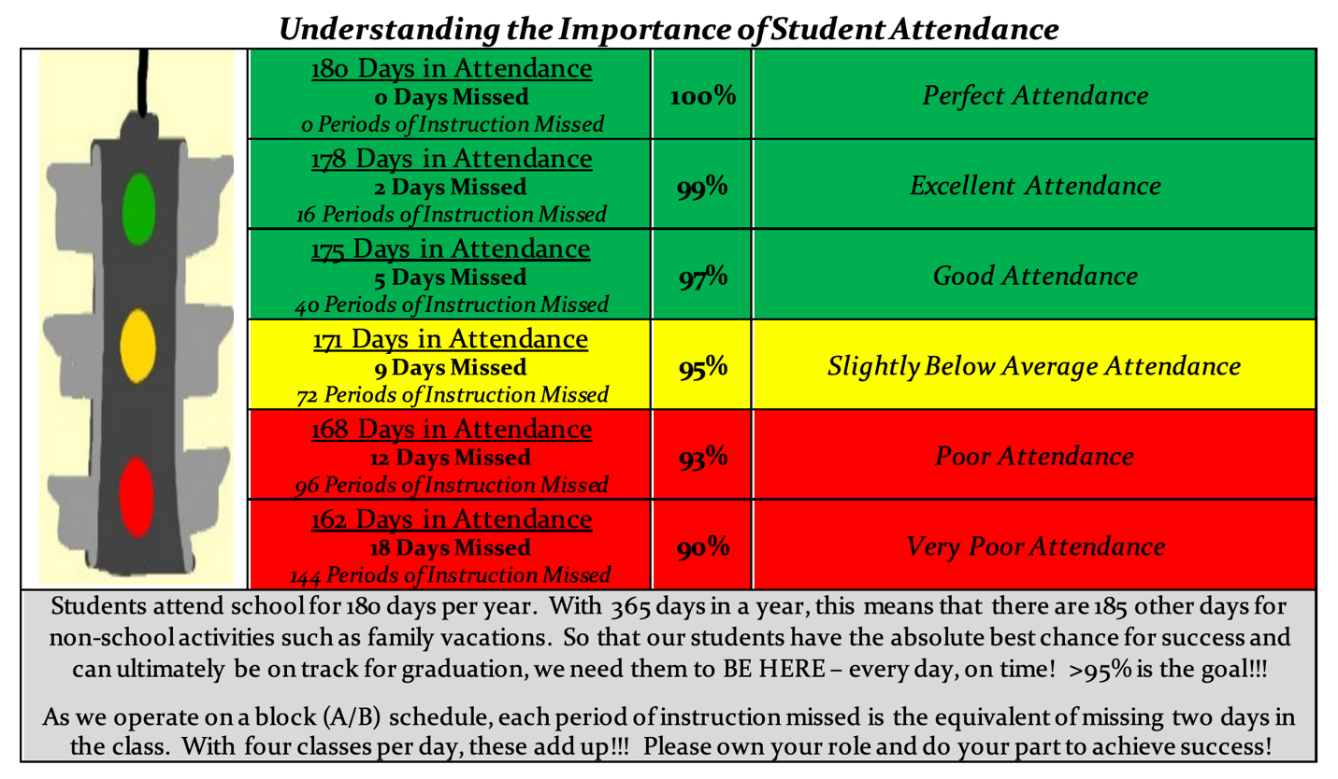

Bell Schedules
The bell schedules for Parkway West High School are as follows:
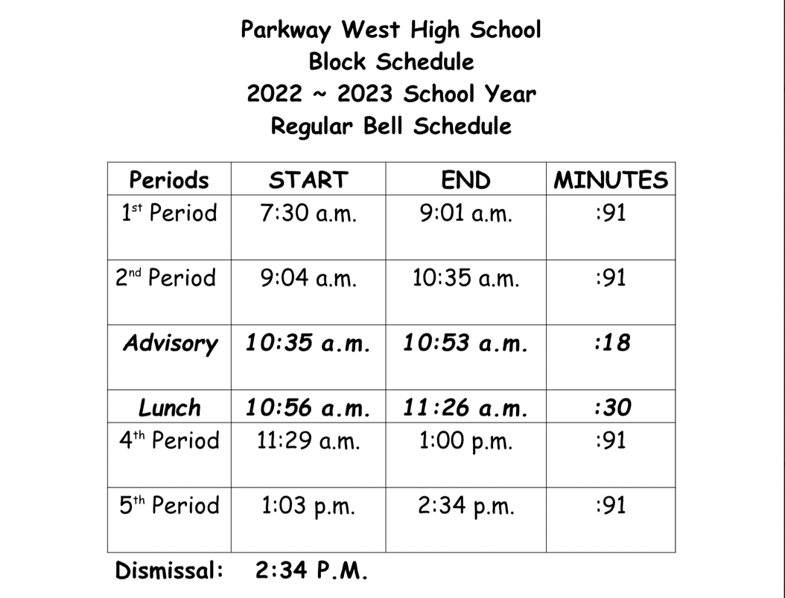
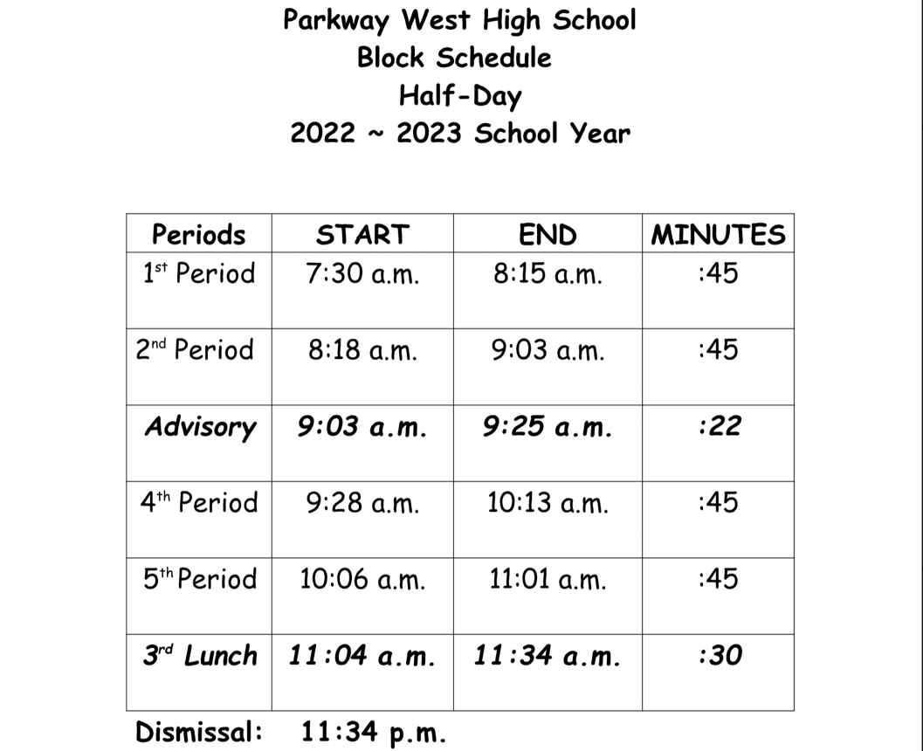

Urban Education Academy at Parkway West High School
In partnership with Philadelphia Academies, Inc., Parkway West High School has implemented an Urban Education Academy that is responsive to the needs of the region and bridges the gap for the preparation, development, and learning of qualified early care and education staff.
Home to the School District of Philadelphia’s only Career and Technical Education (CTE) program for Early Childhood Education, Parkway West’s Urban Education Academy trains program participants to enter a high-demand, high-skill, high-wage career by equipping them with not only core academic skills, but also employability skills and job-specific, technical skills.
Students who successfully complete our three-year Early Childhood Education CTE program can acquire a Pennsylvania Skills Certificate in Child Care & Support Services Management, as well as industry-recognized credentials, facilitating their ability to earn a college degree and/or land a position in field of Early Childhood Education. Accordingly, our program provides our students and their families with immediate benefits, saving them money from escalating college expenses.
Early Childhood Education CTE
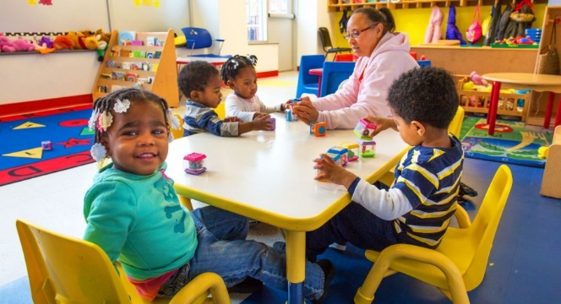
LEVEL ONE LEVEL TWO LEVEL THREE (10th Grade) (11th Grade) (12th Grade)
Coursework
Early Childhood Education 1  Typical and Atypical  Child Development, Cognition, and Learning I  Typical and Atypical  Child Development, Cognition, and Learning II | Early Childhood Education 2  Introduction to Early Childhood Education and Teaching: Grades PreK-4  Introduction to Special Education and Teaching:  Grades PreK-8 | Early Childhood Education 3  Family, School, and Community Collaboration  Internship in Urban Education
Program Assessments
CPR Training First Aid Training | STARS 101 Training STARS 102 Training Act 126 Training | NOCTI Exam CDATM Credential
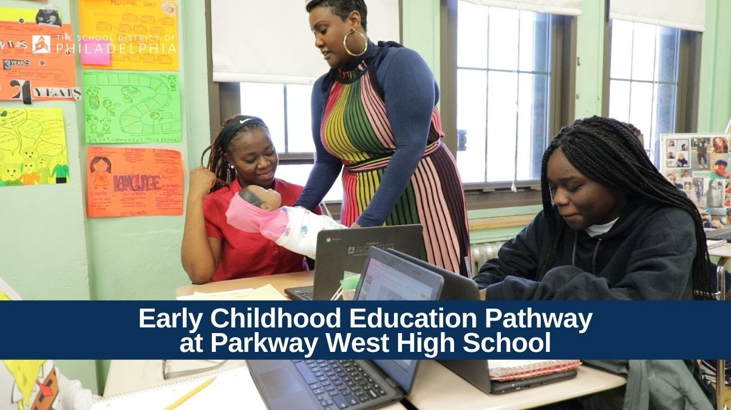
11
Communication Procedures
We value the involvement of families and the engagement of the community in the programs and activities of Parkway West High School. Together, we make the difference, and it is our belief that a team approach is the best one as we work to collectively prepare our students for success in college or career and life.
All school personnel may be reached by telephone by calling the school’s Main Office or via email by sending them an email to their School District of Philadelphia email address.
• Email is generally the best method for contacting school personnel; however, you are asked to keep in mind that email is not designed to replace personal contact.
o Some topics are so sensitive, or require such extended response, that the staff member may opt to respond by telephone or in a face-to-face meeting or conference as opposed to an email.
Staff members will make a reasonable attempt to respond to calls and emails within two (2) business days. Please note that there may be extenuating circumstances, which may prevent a response within this time frame. So that a timely, appropriate resolution may be brought to problems/issues that may present themselves throughout the academic year, we ask that you adhere to the processes listed below to address your concerns.
Concern | Academic (Regular Education Students) | Academic (Special Education Students)
Steps  Contact in this order... | - Teacher  - Mr. Brown | - Teacher and/or  Special Education Case Manager  - Mr. Pasquarello  - Mr. Brown
 | Discipline | Attendance/Truancy
 | - Mr. Cohen  - Mr. Tate | - Teacher  - Ms. Brooks  - Mr. Tate
Possible Concerns
- Academic include, but are not limited to curriculum implementation, instructional delivery, assessment of
student learning, grading policies, progress reporting, homework, and trips.
- Discipline includes, but are not limited to bullying, intimidation, harassment, threats, instigation, or disciplinary responses such as detention, in-school suspension, or out-of-school suspension.
- Attendance/Truancy include, but are not limited to absences, lateness, and early dismissals.
- Other concerns outside of these areas may be directed to the Main Office who will document the concern and route it to the appropriate staff member for review and action.

Remember it is always best to contact the individual closest to the situation so that they can work with you to find a solution!
Emergency Contact Information
In the event of an emergency, it is imperative that Parkway West High School have the most accurate contact information on file for each student. All families are required to complete and submit an “Emergency Contact Form” (EH-4) to be filed in the student’s pocket in the school’s Main Office.
The information included on this form will be used, in part, to update each student’s record in our Student Information System (SIS), Infinite Campus. It is each family’s responsibility to ensure that the emergency contact information on file with the school for their child is accurate and complete. While the school will request updates to this information three times each year, particularly during report card conferences, should a change occur at any time before or after that, the family should notify their child’s Advisor and the school’s Main Office immediately.
An EH-4 form will be sent home with each student during the first week of school and should be sent back to the school.

Morning Admission and Afternoon Dismissal Procedures
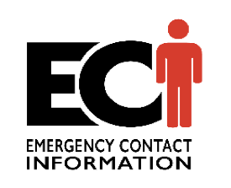
Our school day at Parkway West High School begins PROMPTLY at 7:30 am and ends at 2:34 pm.
As there is limited supervision available before and after those times, we ask and expect that students and families observe and adhere to these procedures for arrival and departure:
Arrival
- All students are expected to arrive no later than and be seated in their rostered first period class by 7:30 am each day.
  - Late students without an appropriate excuse will receive a 15 minute detention.
- Students will enter the building through the front doors facing 48th Street. Students may not enter any other entrance.
- Upon admission to the building, students must swipe their student identification card to capture their attendance and, after being cleared through the safety checkpoint, they are to report to class.
- No parent/caregiver will be permitted to go to the classroom during the school day unless escorted by an administrator.
- Any student who would like to have breakfast may report beginning at 7:10 am.
Departure
- All students will be dismissed at 2:34 pm.
- Students are not permitted to leave school early on their own even if they are 18 or older.
- Unless they are participating in an after-school club, organization, sport, or other approved activity, all students are expected to immediately clear the school grounds upon dismissal.

Breakfast and Lunch Programs
Parkway West High School is a participant in both the National School Breakfast and Lunch Programs, which enables us to provide all our students with a free of cost nutritious breakfast and lunch each day that meets local, state, and federal nutrition standards.
Breakfast is served in the cafeteria from 7:10 - 7:30 each morning in the cafeteria.
Lunch is served in the cafeteria during the school day. There is one lunch period, which occurs mid-day and lasts 30 minutes. Parkway West is a closed campus; students are not permitted to leave the school building for lunch and food deliveries are not allowed!
Uniform Policy
To ensure acceptable standards of dress for all students, the Board of Education of the School District of Philadelphia has adopted a policy for Dress and Grooming.
Board Policy #221 provides for a Uniform Dress Code in each school. As a part of this policy, students are required to dress in a manner adopted by their school. In general, it is our expectation at Parkway West High School that each family ensures that their child observes basic standards of cleanliness, modesty, and good grooming at all times while in attendance at school.
Although PWHS does not have a uniform, students are expected to dress as future educators.
Jeans and shorts are allowed, but no excessive rips or tears that expose skin or undergarments. Pants should also be worn at the waist to keep underwear covered. Shorts and skirts should be long enough to keep underwear covered.
Open-toed shoes such as flip-flops, sandals, and stiletto heels are prohibited and unsafe. Only closed-in shoes or sneakers are allowed.
Shirts should not have any offensive graphics or writing.
See-through or sheer clothing is prohibited. Underwear should be covered.
Remember, some styles are acceptable outside of school, but this is a professional environment, dress accordingly.

Lockers
Parkway West High School assigns each student a locker. Lockers are, and at all times, remain the property of the School District of Philadelphia, subject to search in accordance with Board of Education policy (in Board Policy #226).
For safety reasons, lockers are not to be shared with any other student other than the one to whom it has been assigned. A combination lock is also issued to each student when they receive
their locker assignment. Each student and their parent/caregiver will be provided a Student Locker Contract for their signature, which specifies additional terms and conditions for lock and locker utilization and which must be returned to the student’s Advisor before their locker is assigned.
Rosters
Parkway West High School operates on a semester or 4 by 4 model. Students take the same 4 classes for one semester (half a year) and switch to another set of 4 classes for the second half of the year. This model represents more of the format students will see in college.
Class periods are 91 minutes with a 30-minute lunch and 18-minute advisory period.
Core Curriculum
ACADEMIC INFORMATION
The Pennsylvania Core Standards in English Language Arts and Mathematics, and for other content areas such as Science, Social Studies, World Languages, as well as encore special subjects, the Pennsylvania Academic Standards, inform the scope and sequence of the curriculum,
and thus the content to be taught at each grade level. While curriculum content is generally standardized across schools and within grade levels in the School District of Philadelphia, it is important to note that the instructional methods, assessment techniques, and motivational strategies used by classroom teachers may vary from school to school and classroom to classroom given that the needs, interests, and proficiency levels of the students therein vary.

Core Curriculum Snapshot
9th Grade 10th Grade 11th Grade |  |  | 12th Grade
English  English 1  Social Studies  African-American History  Mathematics  Algebra 1  Science  Physical Science | English  English 2  Social Studies  World History  Mathematics  Geometry  Science  Biology and Environmental Science | English  English 3  Social Studies  American History  Mathematics  Algebra 2  Science  Chemistry | English  English 4  Social Studies  Social Science
Physical Education  Personal Fitness  Health  Wellness  Arts and Humanities  Introduction to Visual Arts | Career and Technical Education  Early Childhood Education 1  Arts and Humanities  Cultural Traditions in the Arts | Career and Technical Education  Early Childhood Education 2  World Language  Spanish 1 | Career and Technical Education  Early Childhood Education 3  World Language  Spanish 2
In addition to the required Core Curriculum courses included in the above snapshot, it is noted that Parkway West High School offers a wide range of Elective courses across various content areas based on our students’ needs according to their achievement data, as well as their interests as expressed in their course requests submitted each academic year. For our highest achieving students, we also offer honors courses and advanced placement(AP)courses
Note that elective courses offerings are subject to change each year based on staffing and student enrollment, but a few of the electives that have been offered in the past include:
Mathematics Science  Arts and Humanities |  |  | General Electives
Pre-Calculus  Math of Personal Finance | Physics Anatomy & Physiology Forensics | Creative Writing Journalism Public Speaking Contemporary Issues Psychology Sociology Drama | SAT Prep - English SAT Prep - Math
16
Assessment Program
A complete program of assessment, inclusive of local, state, and national assessments, is in place to measure and evaluate students’ progress toward mastery of, as well as achievement of proficiency in, the Pennsylvania Core and Academic Standards in English Language Arts, Mathematics, and Science, in addition to students’ readiness for college and/or career.
Parkway West High School, Learning Network Thirteen, and the School District of Philadelphia utilize a variety of assessment techniques to monitor student learning, including screening, diagnostic, interim, formative, and summative assessments. Classroom teachers, in content area Professional Learning Communities (PLCs), collaboratively analyze the results of these assessments during bi-weekly data meetings so that they can fine-tune instructional methods, including providing for small group differentiated instruction.
The Office of Assessment publishes the Assessment Calendar on an annual basis, which specifies the assessments to be administered to the students who attend the school along with the date or window for assessment administration, included below for your convenience.
Achievement Marks
Achievement Marks are not cumulative from one marking period to the next. PWHS runs 0n a semester or 4 by 4 model. Classes last half of a year. The two semester grades are averaged for a final grade at the end of the semester. Each classroom teacher will communicate their course requirements, as well as how grades will be calculated and the protocols for making-up missing or late work, etc. at the beginning of the academic year in their syllabus.
The School District of Philadelphia weights graded assignments by category as follows:
Category Weight
Tests 40%
Performance-Based Learning (e.g., Projects, Labs, Research Assignments, Presentations) 30%
Classwork 20%
Homework 10%
~ From the Marking Guidelines published by the Chief Academic Office

Honors and Awards

Distinguished Honors Meritorious Honors Honorable Mention
The Principal’s Citation  - All As in the four major subjects; no out-of-school suspensions; and, no unexcused absences/latenesses for the reporting period.  - Students attaining Distinguished Honors who have up to and including one (1) unexcused absence/lateness will be considered instead for Meritorious Honors. | The Academy Leaders’ Award  - All As and Bs in the four major subjects; no out-of-school suspensions; and, no unexcused absences/latenesses for the reporting period.  - Students attaining Meritorious Honors who have up to and including two (2) unexcused absences/latenesses will be considered instead for an Honorable Mention. | The Hoya Prize  • All As, Bs, and up to one (1) C in the four major subjects; no out-of- school suspensions; and, no more than three (3) unexcused absences/latenesses for the reporting period.
Other Awards
National Honor Society Parkway STARS Attendance Citizenship
Parkway West High School offers monthly (attendance) and quarterly (academic and citizenship) incentive programs for our students.

Graduation Requirements
Students must fulfill two graduation requirements in order to be conferred their High School Diploma: those adopted locally (in Board Policy #217) and those promulgated at the state level (by Act 158).
School District of Philadelphia Graduation Requirements (Video Link)
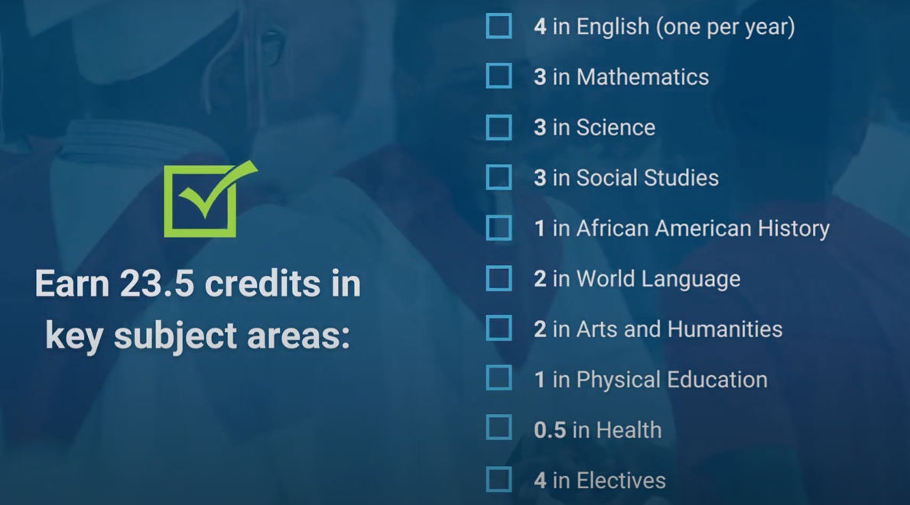
o Demonstrate post-secondary readiness through the successful navigation of one the five pathways:
Pathway 1
- Proficient and/or advanced on all three Keystones
Pathway 2
Keystone Proficiency Keystone Composite
o On each of the three Keystone Exams, achieve a score of 1500 or better
o Take all three Keystone Exams and achieve a composite score of 4452 or better, with:
o A score of “proficient” or “advanced” on at least one Keystone Exam; and,
o No scores of “below basic”
Pathway 3 Pathway 4 Pathway 5
CTE Program Concentrator Alternative Assessments Evidence of Readiness
o Attain an Industry-Based Competency Certification related to the CTE concentrator’s Program of Study; or
o Demonstrate a high likelihood of success on an approved industry-based competency assessment; or
o Demonstrate readiness for continued meaningful engagement in a CTE Program of Study
o Complete a Pre- Apprenticeship Program; or
o Secure admission to an accredited four-year college/university; or
o Take one of the assessments below and achieve the predetermined score:
o PSAT – 970
o SAT – 1010
o ACT WorkKeys – Gold o ASVAB – minimum
score for chosen branch of military service
o Satisfying at least three (3) of the following:
o Letter guaranteeing full- time employment
o Industry-Based Competency Certification
o “Proficient” or “Advanced” score on one Keystone Exam
o Admission to an accredited two-year institution of higher education
o Compliance with NCAA athletic requirements
19
Promotion Standards
The School District of Philadelphia’s Promotion Standards for high school students are provided below, by grade level:
Promotion Standards
10th grade- 5 credits
11th grade- 11 credits
12th grade- 17.5 credits
Students who do not meet these standards will be retained!
Progress Reports – Interim Reports and Report Cards
Students and families at Parkway West High School will be made aware of the student’s academic standing in each of the classes that they receive instruction in on a regular basis.
The School District of Philadelphia issues progress reports, to include interim
Reports and report cards, four(4) times during the academic year. For the first three (3) reporting periods, report cards are provided to families at scheduled report card conferences that occur following that reporting period. For the final reporting period, in June, report cards are sent home with students on the last day of school for the academic year.
Interim reports will include the student’s current average in each class, inclusive of any in-class work, at-home work, papers/projects, quizzes, and tests that have been assigned to date. Their report card will list their achievement mark in each course, as well as any comments from the classroom teacher who provides direct instruction in that course. Student attendance to date, including absences and latenesses, are also included on the student’s report card.
Families are asked to review the Interim Reports with their children. Once they have done so, you sign and return it to the school within three (3) school days.
Field and Class Trips
At Parkway West High School, classroom teachers may, from time to time, plan a field or class trip for the students who are in their classes.
Trips are an extended learning opportunity, the intention of which is to supplement the instruction provided to students within the classroom in a given content area.
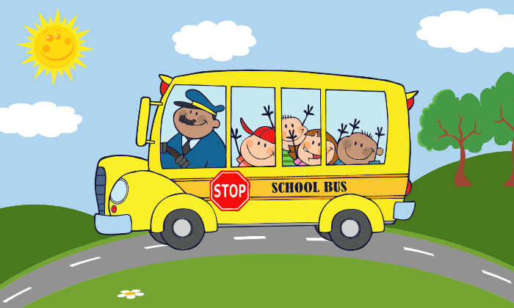
Except for “walking” trips in and around the neighborhood, which may be taken at any time and that students may participate in provided a signed “Parental Permission Form” (EH- 80) is on file with the school, for the 2023/2024 academic year.

Student Records
STUDENT SUPPORT INFORMATION
The School District of Philadelphia maintains a variety of student records, the confidentiality of which is maintained in accordance with state and federal laws and regulations and Board of Education policy (in Board Policy #216).
District personnel, as well as parties acting for the District may access a
student’s records provided a legitimate educational interest exists. Parents/caregivers, including any natural or adoptive parent, legal guardian, or individual acting as parent in the absence of a parent/caregiver (i.e., a surrogate), have the right to examine a student’s records and to be provided with copies of any records maintained in a timely manner, upon their request, unless the District has been provided with evidence that there is a court order or other legally-binding document governing such matters as divorce, separation, or custody that specifically revokes these rights. The right of access only covers the right to information in the student’s records that are about that student; it does not include or extend to any information in the student’s record that are or may be about any other student.
Parkway West High School requires, in accordance with the Family Educational Rights and Privacy Act (FERPA), written permission from a student’s parent/caregiver to release any information from the student’s record; however, student records may be disclosed, without consent, to schools of intended enrollment or to any other entity or under any of the conditions specified by law in 34 CFR§99.31. In those instances where a student has damaged, destroyed, or not returned loaned property of the school and restitution has not been made, the school reserves the right to withhold student records from a parent/caregiver, but will not withhold any record from a school of intended enrollment or any other entity legally entitled to them under law.
Attendance
Students at Parkway West High School are
AIMING HIGH AND STRIVING FOR 95...
Parkway West Students do not miss more than nine because they want to learn and not fall behind!
Commonwealth of Pennsylvania law and Board of Education policy (in Board Policy #204) require that all children of “compulsory school age” who reside in Philadelphia County attend school regularly. In addition to regular attendance, it is expected that students are on time to school.
When it is necessary for a student to be absent from school, to have
the absence coded as “excused,” it is the responsibility of parents/caregivers to, within three (3) days of the student’s return to school, provide a signed, dated note indicating the reason(s)that the student was absent. If a note is not presented to the school within this timeline, the absence will be coded as “unexcused” and the School District of Philadelphia’s truancy process will be followed by Parkway West High School staff.
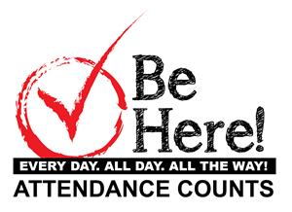
Please also note the following as it relates to District policy regarding absence notes:
- Absences totaling three (3) or more consecutive days require a doctor’s note; and,
- Those absences excused with a parent note, totaling eight (8) days (cumulatively in one
academic year), all subsequent absences require a doctor’s note.
Just because an absence note is presented does not mean that the absence(s) will be coded as excused...
An administrator will make the determination as to whether the note will be accepted. Generally speaking, an absence for any of the reasons below will be considered to be and coded as excused:
Code Absence Reason
- 4 Excused Early Dismissal
- 5 Illness
- 6 Quarantine
- 7 Recovery from Accident
- 8 Required Court Attendance
- 9 Death in Family
- 10 Educational Tours and Trips (with Prior Approval)
- 11 Excused Religious Holiday
13 Excused Lateness
15 Out of School Suspension
Reasons that fall outside of the scope of those listed above will be deemed invalid and the absence will remain coded as unexcused.
Early Dismissals
School District of Philadelphia policy, as written in the “Special Release Procedures,” requires that a parent, legal guardian, or other responsible adult who the parent/guardian has indicated, in writing, must report to the school office to sign a student out before the student is released for early dismissal from the school.
Special Release Procedures for Early Dismissal:
- Individuals who are picking up a student for an early dismissal from Parkway West High School MUST be listed in Infinite Campus, the Student Information System (SIS).
- Any adult who comes to take a student out of school early must ALWAYS show photo identification prior to any early dismissal being granted.
THERE WILL BE NO EXCEPTIONS!!!
Per District policy, any student coming to school two (2) hours after the start of the school day or leaving two (2) hours before the end of the school day, will be marked as half-day absent. If a verifiable note from a medical provider is supplied to the school within 24 hours of the appointment/visit, the absence will be marked as excused; if a note is not provided, the absence will remain unexcused. In any event, two (2) half-day absences will equal one (1) full day absence.
Multi-Tiered Systems of Support (MTSS)
Multi-Tiered Systems of Support (MTSS) is a prevention framework that organizes building-level resources to address each individual student’s academic and/or behavioral needs within intervention tiers that vary in intensity. MTSS allows for the early identification of students who are at risk for poor learning outcomes. The increasingly intense tiers(i.e.,Tier1- 3), sometimes referred to as levels of prevention, represent a continuum of supports. Response to Instruction and Intervention (RtII) and Positive Behavior Interventions and Supports (PBIS) are examples of MTSS.
Response to Instruction and Intervention (RtII) is an early intervening support process where the goal is to improve student achievement using research-based interventions matched to the instructional needs and achievement levels of the student.
The core of RtII is the premise that ALL children can learn, and in Pennsylvania, RtII carries dual meaning:
1. First, it is a comprehensive, multi-tiered, standards aligned strategy to enable early identification and intervention for students at-risk.
2. Second, RtII is an alternative to the aptitude achievement discrepancy model for the identification of students.
MTSS-RtII allows educational professionals to identify and address individual and group needs and challenges while also building on student strengths. Monitoring student response to a series of increasingly intense interventions assists in guiding instruction to prevent student academic failure and provides data that may guide eligibility decisions for special education placement.
For the 2023/2024 academic year, Parkway West High School students will have access to Achieve 3000, which will be our schoolwide Tier 1-3 academic intervention.
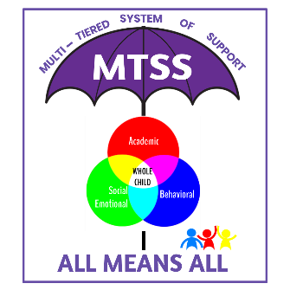
Child Abuse
Per the Child Protective Services Law, all School District of Philadelphia employees and any independent contractors are mandated reporters. Accordingly, we are required to make a report in any situations where reasonable cause exists to suspect that a student is being physically, emotionally, or sexually abused or neglected in any way.
Aside from the School Counselors, Administration and, when appropriate, the School Nurse, reports about and any discussions regarding suspected child abuse are kept confidential. District employees and third-party contractors will absolutely cooperate with any investigators from the Philadelphia Department of Human Services (DHS) and/or law enforcement as they investigate reports of suspected child abuse and/or parental neglect.
Pupil Personnel Services Team
Our Pupil Personnel Services Team at Parkway West High School is comprised of the following licensed educational specialists who have intersecting and overlapping, yet distinctive roles that allow them to support our students’ wellness needs:
- School Counselor
- School Nurse
- School Psychologist
- School Speech and Language Pathologist
We are fortunate to have a core team of professionals at our school who are individually and collectively committed to our students’ success and that work diligently to ensure that every student who attends Parkway West High School can make meaningful progress through their support of the instructional program.
Ms. Drago, our School Counselor, provides opportunities for the academic, college/career, and social-emotional development of all our students through individual and group guidance and counseling. They deliver direct services to students, as well as provide administrative consultation, facilitate staff collaboration, and coordinate family engagement.
Our School Nurse Mrs. Sadler provides medical care for student and employee illnesses, injuries, and emergencies. She also maintains health and immunization records for all students, performs state-mandated screenings, and administers medications. In addition, the School Nurse acts as a consultant to school staff and families in health-related matters, provides referrals and, on occasion, delivers classroom instruction on health-related topics.
Ms. Breuing, our School Psychologist, supports the ability of our students to learn and of our classroom teachers to teach by drawing on her experience and expertise and applying her training in psychology and education to help each student succeed. She provides direct support to students, as well as consults with school staff and families to improve support strategies while also working with administration to improve schoolwide practices and policies and collaborating with community providers to coordinate needed services. Additionally, the School Psychologist assists the Multidisciplinary Team in determining a student’s eligibility to receive special education services.
Our Speech and Language Pathologist, Ms. Pacharis, evaluates the speech, language, and communication strengths and needs of students, designing and delivering therapy to students determined to have a disability in approving their communication ability.
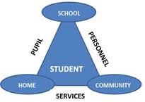

Hospital and Homebound Instruction
The School District of Philadelphia offers a Hospital and Homebound Instruction program for students who are unable to attend school because of a temporary or long-term documented medical issue, including pregnancy.
This service, which requires an application that includes completion and submission of a signed “Physician’s Referral for Homebound Instruction” (SEC- 137A) and “Homebound Instruction - Letter to Parent” (MEH-210) to the School Nurse, is intended to provide the student with some level of instruction during
their period of absence so that, upon return to school, they can successfully reengage with the school’s instructional program.
If, at any time during the academic year, a need arises for your child to receive hospital and/or homebound instruction, please notify the School Nurse so that the request can be reviewed by the Office of Student Health Services.
Special Education
The School District of Philadelphia and the Philadelphia Intermediate Unit (IU 26) provide special education and related services to children with disabilities that reside in Philadelphia County and who are three (3) to twenty-one (21) years of age.
Special Education provides support in helping
children with special needs gain access to
appropriate education. Students may be
identified as needing special education services
when a multidisciplinary evaluation determines
that a student has a disability and requires
specially designed instruction. Both the District and IU 26 have “screening” and “evaluation” procedures to identify children who need special education services.
Programming available at Parkway West High School include:
- Autistic Support
- Learning Support
- Speech and Language Support
Related Services, who are support services, that help students with disabilities benefit from their special education program, are also available.
For more information, please review the “Annual Notice of Services for Students with Disabilities including Special Education and Protected Handicapped Students,” which can be found on the Office of Specialized Services webpage at https://www.philasd.org/specializedservices or contact the school to speak with Mr. Pasquarello or Mr. Roundtree.
English Language Development (ELD)
For students whose first language is not English or who may be of limited English proficiency, the School District of Philadelphia offers an English Language Development (ELD) program.
Referred to previously as English to Speakers of Other Languages (ESOL), ELD programs provide students who are learning English with specialized language instruction and content area support. English Learners (ELs) are taught the language through skills-based instruction in the core language processes of reading, writing, speaking, and listening.
Students who are newly admitted to the School District of Philadelphia will be administered an assessment to determine their instructional needs and if placement in the ELD program is necessary provided the Home Language Survey, which is completed as a part of the enrollment process, indicates that a language other than English is spoken at home.
For more information, please contact the school to speak with Ms. Franklin.
Transportation
A student’s eligibility for transportation to and from school is determined by the School District of Philadelphia’s Transportation Eligibility Guidelines.
For non-handicapped regular education students, mileage,
grade level of the student, location, and residency are the factors to which due consideration is given. Students with disabilities who receive special education services and that require special transportation or additional support must have this documented in their most recent finalized Individualized Education Plan (IEP).
Students who receive a Student Fare Card
Students that attend Parkway West High School who receive a Student Fare Card will be provided with their Student Fare Card by Ms. Brooks on the first day of school.
Bus Riders
The parent/caregiver of a student that rides a bus will be sent a Parent Notification Letter (PNL) from the Office of Transportation, which indicates the student’s assigned route number and their pick-up time and location. PNLs are generally sent out one week prior to school opening. While on the bus, students are expected to observe and adhere to the rules set by the Bus Chauffer and any Bus Attendants on their route. Failure to do so may result in disciplinary action, including a bus suspension.
Questions about transportation may be directed to the Office of Transportation, which can be reached at 215.400.4350.

Student Code of Conduct
The School District of Philadelphia has adopted a Student Code of Conduct to communicate and reinforce to the entire school community, the behaviors and conduct that are expected of all students, as well as the interventions and incentives that students will be subject to should they or should they not meet these expectations. All students must adhere to the Student Code of
CLIMATE AND SAFETY INFORMATION
Conduct before, during, and after school. It applies in the building, on the grounds, at school- related activities and events on or off the campus, and on the way to and from school.
Understanding that the teaching and learning process is intended to teach, challenge, and support each student in realizing and achieving their maximum learning potential, schools and classrooms must be supportive environments that are caring, orderly, positive, and safe and which are also characterized by individual responsibility and mutual respect. To ensure that this environment is maintained, the Administration reserves the right to discipline any student found responsible for violating the Student Code of Conduct by imposing disciplinary action to address and correct annoying, disruptive, severe, or pervasive behaviors.
Defining Discipline: Parkway West High School holds the collective belief that discipline is a process that incorporates teaching, modeling, and timely and appropriate responses to modify unacceptable behavior and conduct for the purpose of maintaining a safe and secure atmosphere.
Progressive Discipline
The goal of progressive discipline is to assist students in seeing that both a behavioral problem and an opportunity for improvement exists. In a progressive discipline system, disciplinary action is imposed relative to the nature and scope of the violation, and in the system we use at Parkway West High School, repeated violations of the Student Code of Conduct result in greater penalties being imposed for each violation.
While the Administration has elected to approach discipline progressively, even with our School Plan goal in mind, it must be noted that any serious violation, which threatens the health, safety, and welfare of other students, staff, or visitors to Parkway West High School may unfortunately result in an immediate out-of-school suspension and possibly more severe disciplinary.
Because we are a community and the actions of individuals have an effect on the entire group, we feel that it is important to make it known, in advance, that students who aid, abet, encourage, request, initiate, assist, or have knowledge of another student’s participation in acts that violate the Student Code of Conduct and who does not report it to an administrator or staff member will be subject to disciplinary action as if he/she had actually committed the violation.
Any student who is suspended may not attend or participate in any school-sponsored activities or events, on or off school grounds, during the period of that suspension.
Interscholastic Athletics and Co-Curricular and Extra-Curricular Activities
Parkway West High School is pleased to offer a variety of co-curricular and extra-curricular activities, as well as interscholastic athletics for our students.
The clubs, organizations, and sports we host or that we offer in cooperation with West Philadelphia High School include:
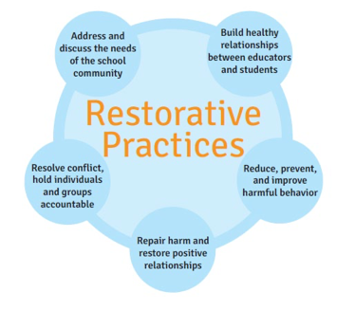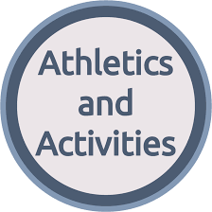
Clubs and Organizations
Sports
(at Parkway West HS) (with West Philadelphia HS)
Chess Club National Honor Society Poetry Club Special Olympics Student Government Tutoring Yearbook | Basketball (B, G) (JV, V) Softball  Track & Field (C) Volleyball (B, G) | Badminton Baseball Bowling Cheerleading (C) Cross Country (C) Football (JV, V) Lacrosse (B, G) Soccer (B, G) Wrestling (B, G)
G – Girls B – Boys C – Co-Ed JV – Junior Varsity V – Varsity
Note that the clubs and organizations that are available at the school are subject to change from one academic year to the next, contingent upon the willingness and availability of a staff member or, when appropriate, an approved organization to sponsor the activity. Students are invited to participate in as many activities as their interests, time, and parent/caregiver allow. Participation in most activities, specifically extra-curricular activities and interscholastic athletic programs, require that students meet the academic eligibility standards set forth by the School District of Philadelphia in addition to the Pennsylvania Interscholastic Athletic Association (PIAA).
Any student who is absent from school is not eligible for participation in an activity on the date of the absence. In addition to the “Parental Permission Form”(EH-80),those students who are members of a sports team must also have a “PIAA Comprehensive Initial Pre-Participation Physical Evaluation” on file with the school.
For more information, please contact the school to speak with the Activity Sponsor or Mr. Beaton.
Electronic Devices
School District of Philadelphia policy prohibits the use of cell phones in schools by students and holds that cell phones may be confiscated if a student is found to be in possession of a cell phone or believed to be using the device inappropriately.
School administrators are given the autonomy and flexibility to craft policies at the school level for possession and use of cell phones in the school building.
At this time, the Administration at Parkway West High School has determined that cell phones, while possessed, will not be permitted to be used in the building and that noncompliance with this policy will be handled as follows:
- The first instance will result in the cell phone being confiscated and returned to the student at the end of the school day; the parent/caregiver will be notified of this by telephone or via email.
- The second instance will result in the cell phone being confiscated and returned only to the parent/caregiver who may pick the item up from the Dean of Students or the Principal at the end of the school day.
- Should there be a third instance of the policy being violated, the item will again be confiscated and returned only to the parent/caregiver after a 30-day hold.
Continued instances of noncompliance with this policy will also result in disciplinary action.
Parkway West Administration and staff will NOT – under any circumstances – be responsible for any lost, stolen, or damaged electronic devices, including and especially cell phones!!!
Social Media and Internet Usage
As “citizens of the world” in a global, technological, and multidimensional society that is constantly evolving, proficiency in the use of various technology applications, as well as the Internet is essential for individuals to be informed, responsible citizens.
While it is the goal of the instructional staff at Parkway West High School to incorporate technology and, on occasion, social media into the learning activities and experiences that they engage their students in within their classrooms, students have a responsibility to use the Internet and social media applications responsibly.
Irresponsible use of technology in and out of school, including for bullying, harassment, intimidation, or other potentially illegal purposes will lead to disciplinary action. Where appropriate, the Philadelphia Police Department may also be notified and the student(s) involved may be subject to civil, criminal, or other penalties as defined by law. Building Security
Parkway West High School welcomes families and other visitors to our school with the hope that their visit will be enjoyable and enlightening.
The only entrance that visitors to the Sulzberger School Building are to use to gain access to the building is the Visitor Entrance, located on 48th Street.
Visitor Protocols:
- Those wishing to enter the building should ring the bell outside of the Visitor Entrance and, when greeted, indicate that they are a visitor for Parkway West.
- Upon entry, visitors are asked to check-in at the desk located in the atrium where they will need to show photo identification and be signed-in on the visitor register.
- After being checked-in, visitors must report directly to the Parkway West Main Office, which is located on the 2nd Floor where, if necessary, they will be given a Visitor’s Pass, met by a staff member, and escorted to their destination.
Safe2Say Something
SAFETY IS EVERYONE’S RESPONSIBILITY...
If you see something, say something!
Safe2Say Something (S2SS) is an anonymous reporting system mandated under Commonwealth of Pennsylvania law (in Act 44) for use by students in grades 6-12. A youth violence prevention program, S2SS is administered by the Office of the Attorney General.
Visitor Entrance on Fairmount Avenue
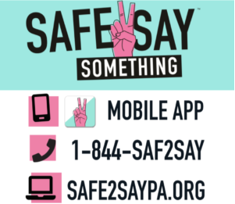
The program educates students, staff, and others about the warning signs and signals, with special attention to social media, from individuals who could potentially be a threat to themselves or others and to say something before it is too late. All reporting is easy and confidential.
More information can be found about S2SS at https://www.safe2saypa.org.
Emergency Evacuation and Safety Drills
Safety Drills including, but not limited to fire, lockdown, and shelter-in-place are held throughout the academic year, as required by the School District of Philadelphia and included within the Parkway West High School Safety Plan. These drills are executed to familiarize our students and staff with the procedures they are to follow during any one of these types of emergencies.
For the safety of all persons occupying the school building, it is essential that order and discipline be maintained at all times during a practice drill or an actual emergency situation and that the procedures specific to the emergency be followed. Noncompliance will result in disciplinary action.
If an emergency evacuation becomes necessary, Parkway West’s students and staff will be relocated to James Rhoads Elementary School, located at 4901 Parrish Street, Philadelphia, PA 19139.
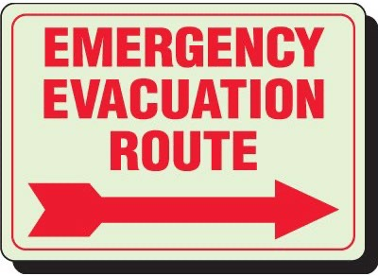
HOME, SCHOOL, AND COMMUNITY INFORMATION
School Advisory Council
Parkway West High School, in continuing our joint work of providing our students with an authentic, transformational, and liberating educational experience that prepares them for success in college or career and in life, while recognizing that this work is never-ending, also realizes that the work cannot be done without all of us coming together and uniting.
In working to achieve our shared vision and, in our efforts to bolster family involvement and community engagement, during the 2021/2022 academic year, we are relaunching our School Advisory Council(SAC). The SAC includes stakeholder representation from the various constituent groups of the school community and its work focuses on three areas: (1) supporting academic achievement, (2) improving school climate and culture, and (3) strengthening family involvement.
In support of this work and among its many advisory duties, the SAC is responsible for promoting strategic, collaborative conversations and facilitating student-centered decision-making relative to: • School Level Plan • Climate and Safety
• Budget • Family Involvement & Community Engagement
If you are interested in the opportunity to serve on the SAC, you are asked to contact Mr. Brown about the requirements and qualifications for serving, as well as the meeting times and dates.
Home and School Association
The Home and School Association (HSA) at Parkway West High School
plays a vital role in the school community by serving as an outlet for all
families to regularly interact directly with our school leadership, working
with them to find solutions to common problems, resolutions for shared
issues, and consensus for areas of mutual concern so that together, we get
results for our students! With a committed HSA comprised of invested
families, student grades will be higher, test scores will improve, and attendance will increase.
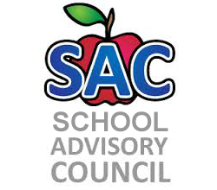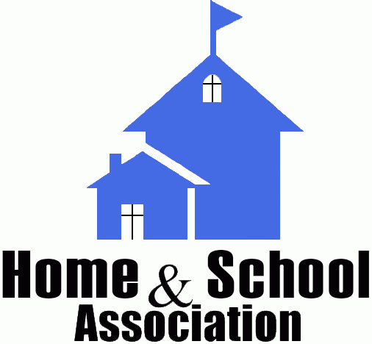
Student Government
Intent on providing our students with hands-on preparation for full and active participation in the civic affairs of our City, this Commonwealth, and the nation following their graduation from high school and, in alignment with the Board of Education’s
Guardrail Two (Enriching, Well-Rounded Experiences), Parkway West High School’s Student Government promotes the power of student voice and agency in both classroom and non-classroom settings throughout our school community.
Comprised of appointed and elected student representatives from each Advisory cohort, the Student Government advocates for interests of their peers with our school leadership by providing input and offering feedback about school affairs. In addition to this,the Student Government helps foster connections among and between students and staff, create a sense of belonging for all students at the school, and encourage school pride through service projects and other activities.
The Student Government will select two students to serve as delegates to the Citywide Student Government and the Principal, following consultation with the Student Government Officers and their Advisor, will select at least one additional student to represent the school on the Superintendent’s Student Advisory Board.
Parent & Family Portal
In an effort to keep families apprised of student progress in real time, the School District of Philadelphia has created an online Parent & Family Portal, which provides families with access to their child’s profile, inclusive of academics, attendance, behavior, and other pertinent information.
Families are strongly encouraged to monitor the Parent & Family Portal on a regular basis, but are reminded that this communication method does not replace regular in-person, telephone, or email contacts with school staff.
To register for the Parent & Family Portal, please visit http://signup.philasd.org. The registration may be completed using any computer, tablet, or mobile phone.
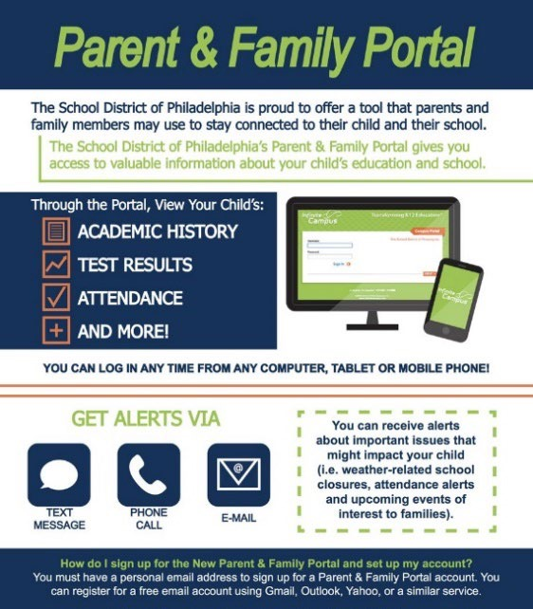
Volunteers
The administration, staff, and students of Parkway West High School appreciate the “in-kind” donation of time and talent by adults, including parents/caregivers and members of the community-at-large, who wish to volunteer in our school.
In accordance with Board of Education policy (in Board Policy #916) and Office of Family and Community Engagement (FACE) procedures, before they are permitted to volunteer in our school, an individual must:
- Obtain the necessary clearances. The safety of our students is our top priority, so we require all adult volunteers to obtain clearances before they begin volunteering in the school.
- Attend our Volunteer Orientation, either in-person or online. Before volunteering in a School District of Philadelphia school, interested adults will need to learn more about the basics of volunteering and recognizing the signs of child abuse. The orientation can be completed at the Education Center (440 North Broad Street), here at Parkway West, or online.
There is no cost associated with obtaining clearances to volunteer! Upon request, school staff will gladly assist those adults who wish to volunteer at Parkway West with completing the clearance process. Once the necessary clearances have been obtained and the Volunteer Orientation has been completed, copies of these documents should be brought to the school, taken to the Main Office, and given to Dr. McCladdie, who will file them.
Clearances are valid for 60 months (five years) from the date of issuance of the oldest clearance.
Chaperone Policy
School District of Philadelphia administrative procedures specify that there shall be one adult chaperone for every ten students who attend a school-sponsored field or class trip or social event.
Parkway West High School welcomes parents/caregivers and other responsible adults connected with a student whose class will be participating in a field or class trip or social event to attend and serve as a chaperone with approval from the Administration.
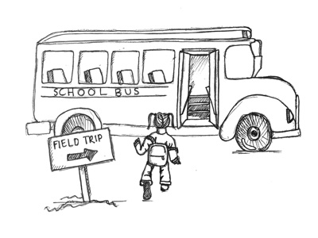
Note that to serve as a chaperone for a field or class trip or social event, the process for becoming a volunteer must have been completed.
34
American Education Week
Now in its 100th year, American Education Week, which was originally co-sponsored by the National Education Association and the American Legion, presents a wonderful opportunity to all Americans. Observed by thousands of schools nationwide, during American Education Week we celebrate all things related to public education. Parkway West High School is particularly excited for this week because it underscores the
critical need to provide every child with a quality public education and we will be honoring those individuals who are making a difference on that front.
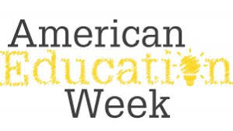
Celebrations
It is the professional opinion of the Administration that next to children, instructional time is among the most valuable assets present in and available to a school. Holding this belief, it is our practice to protect and safeguard the time allotted for learning and teaching from unnecessary disruptions.
While we feel that celebrations are important, we encourage you to celebrate your child’s birthday and other special events outside of school time so that your child and other children who attend our school do not miss out on instruction. Under no circumstances will we authorize birthday parties or any other celebrations to be held in classrooms. As a part of our efforts to promote inclusion in our school we will, instead, hold a schoolwide celebration of birthdays and other extraordinary occasions during one of our Advisory Periods or an alternate time each month.
School-Parent Compact
The administration, staff, families, and community of Parkway West High School continue to unite around a common goal – ensuring that our students are provided with the authentic, transformational, and liberating educational experience they deserve and are entitled to so that they will be prepared to enjoy success in college or career and in life as altruistic citizens.
To understand how working together can benefit your child, it is first important to understand the Board of Education’s and school’s goals for high school students.
THE BOARD OF EDUCATION’S GOALS AND GUARDRAILS: 2020-2026
(as applicable to High Schools)
- Goal 4 (College and Career): The percentage of students who are proficient on all three state high school assessments (Algebra, Biology, and English Literature) by the end of their 11th grade year will grow from 22.2% in August 2019 to 52.0% by August 2026.
- Goal 5 (College and Career): The percentage of Career and Technical Education (CTE) students who pass an industry standards-based competency assessment by the end of their 12th grade year will grow from 49.9% in August 2019 to 80.0% in August 2026.
- Guardrail 1 (Safe, Welcoming Schools): Every school will be a safe, welcoming, and healthy place where our students, staff, and community want to be and learn each day. This means that our schools will be: 1) environmentally safe and clean; and, 2) spaces with inclusive climates that provide students with access to robust social, emotional, and mental health supports.
- Guardrail2(Enriching,Well-RoundedExperiences):Everystudentwillhaveawell-rounded education with co-curricular opportunities, including arts and athletics, integrated into the school experience.
- Guardrail 3 (Partnerships): Every parent and guardian will be welcomed and encouraged to be partners in their child’s school community.
- Guardrail 4 (Anti-Racism): Our students’ potential will not be limited by practices that perpetuate systemic racism and hinder student achievement.
To help your child meet the district and school goals, the school, you, and your child will work together as follows:
School Responsibilities
Parkway West High School will:
- Provide for relevant and rigorous learning activities and experiences that are aligned with the Pennsylvania Core and/or Academic Standards and which recognize and are responsive to individual student needs and interests.
- Establish a caring, orderly, positive, and safe school and classroom environment where all students can realize and achieve their maximum learning potential.
- Maintain open lines of communication with parents/caregivers about their child’s progress, achievement, and behavior while at school; this includes honoring requests for meetings or conferences and promptly returning phone calls and emails (within 48 business hours).
Parent/Caregiver Responsibilities
We, as parents/caregivers, will:
• Be knowledgeable about and familiar with the expectations and standards established by the school district and school, being available to classroom teachers and school leaders at all times by maintaining current contact information so that I can be contacted when necessary.
  - Check my child’s Google Classroom, as well as the Parent & Family Portal; sign and return interim reports; attend and participate in report card conferences; and, cooperate with the school team in helping my child when academics, behavior, or attendance become a concern.
  - Provide my child with the necessary support to ensure that he/she is prepared for school and ready to learn each day. This includes, however, is not limited to the provision of proper nutrition, adequate sleep, and a quiet place to study.
Student Responsibilities
We, as students, will:
    - Attend class daily, on time, prepared, and ready to learn with the required materials, always putting forth my best effort in all that I do and asking for help when I need it.
    - Be aware of and adhere to all policies, rules, procedures, and regulations set forth by the classroom teacher and school leaders.
    - Be tolerant of the differences present within the classroom environment, treating others the way I want to be treated and not participating in any activities, which interfere with others’ right to learn or feel safe and secure in the classroom.
Communication About Student Learning
Parkway West High School is committed to frequent two-way communication with families about children’s learning. Some of the ways you can expect us to reach you are:
- School Website – regularly updated with information about school policies and procedures, as well as updates about school programs, activities, and other items.
- Student & Family Information Guide – provided in September for all students and upon enrollment at the school for new and transfer students; posted on the school website.
- Monthly School Calendar – sent home with students and posted in the school office and online on the school website and on Google Classroom at the beginning of each month.
- Parent-Community Workshops – offered at various intervals throughout the academic year and focused on topics that are relevant to children and families.
Activities to Build Partnerships
Parkway West High School offers ongoing events and programs to build partnerships with families:
  - Family Volunteerism and Advocacy Opportunities
  - School Advisory Council
  - Home and School Association
  - Back to School Night
  - Workshops
Parent and Family Engagement Policy
In support of strengthening student academic achievement, Parkway West High School receives Title I, Part A funds and therefore must jointly develop with, agree on with, and distribute to parents and family members of participating children a written parent and family engagement policy that contains information required by section 1116(b) and (c) of the Every Student Succeeds Act (ESSA).
The policy establishes the school’s expectations for parent and family engagement and describes how the school will implement a number of specific parent and family engagement activities, and it is incorporated into the school’s plan submitted to the local educational agency (LEA).
The Parkway West High School agrees to implement the following requirements as outlined by Section 1116:
- Involve parents, in an organized, ongoing, and timely way, in the planning, review, and improvement of programs under Title I, Part A, including the planning, review, and improvement of the school parent and family engagement policy and the joint development of the schoolwide program plan under Section 1114(b) of the Every Student Succeeds Act (ESSA).
- Update the school parent and family engagement policy periodically to meet the changing needs of parents and the school, distribute it to the parents of participating children, and make the parent and family engagement policy available to the local community.
- Provide full opportunities, to the extent practicable, for the participation of parents with limited English proficiency, parents with disabilities, and parents of migratory children, including providing information and school reports required under Section 1111 of the ESSA in an understandable and uniform format, including alternative formats upon request and, to the extent practicable, in a language parents understand.
- If the schoolwide program plan under Section 1114(b) of the ESSA is not satisfactory to the parents of participating children, submit any parent comments on the plan when the school makes the plan available to the local educational agency.
- Be governed by the following statutory definition of parent and family engagement and will carry out programs, activities, and procedures in accordance with this definition:
Parent and Family Engagement means the participation of parents in regular, two-way, and meaningful communication involving student academic learning and other school activities, including ensuring:
o Parents play an integral role in assisting their child’s learning
o Parents are encouraged to be actively involved in their child’s education at school
o Parents are full partners in their child’s education and are included, as appropriate, in decision-making and on advisory committees to assist in the
education of their child
o Other activities are carried out, such as those described in Section 1116 of the ESSA
DESCRIPTION OF HOW THE SCHOOL WILL IMPLEMENT REQUIRED SCHOOL PARENT AND FAMILY ENGAGEMENT POLICY COMPONENTS
Section A: JOINTLY DEVELOPED
Parkway West High School will take the following actions to involve parents in an organized, ongoing, and timely manner in the planning, review, and improvement of Title I programs, including opportunities for regular meetings, if requested by parents, to formulate suggestions and to participate, as appropriate, in decisions relating to the education of their child and respond to any such suggestions as soon as practicably possible.
  - Each academic year, the school will invite the families of the children who are enrolled at the school to attend and participate in meetings to review and discuss Title I programming at three different points in the year – Fall, Winter, and Spring.
  - The school also has an active School Advisory Council (SAC) and, secondarily, a Home and School Association (HSA), both of which are vehicles through which families can learn more about current and planned school activities and where they can take part in the decision- making process.
  - A variety of workshops, which are led by school and District staff and, on occasion, by community partners will also be made available to families in support of increased parental involvement and additional community engagement.
Section B: ANNUAL TITLE I MEETING
Parkway West High School will take the following actions to conduct an annual meeting, at a convenient time, and encourage and invite all parents of participating children to attend to inform them about the school’s Title I program, the nature of the Title I program, the parents’ requirements, the school parent and family engagement policy, the schoolwide plan, and the school-parent compact.
- Each academic year, the school will invite the families of the children who are enrolled at the school to attend and participate in meetings to review and discuss Title I programming at three different points in the year – Fall, Winter, and Spring.
- All families will be afforded the opportunity to provide feedback about the educational program on an annual basis by completing the Parent Survey.
Section C: COMMUNICATIONS
Parkway West High School will take the following actions to provide parents of participating children with (1) Timely information about the Title I programs, (2) Flexible number of meetings, such as meetings in the morning or evening, (3) transportation, child care or home visits, as such services relate to parent and family engagement and may use Title I funds and (4) Information related to the school and parent programs, meetings, and other activities, is sent to the parents of participating children in an understandable and uniform format, including alternative formats upon request and, to the extent practicable, in a language the parents can understand.
- School Website – regularly updated with information about school policies and procedures, as well as updates about school programs, activities, and other items.
- Student & Family Information Guide – provided in September for all students and upon enrollment at the school for new and transfer students; posted on the school website.
- Monthly School Calendar – sent home with students and posted in the school office and online on the school website and on Google Classroom at the beginning of each month.
- Parent-Community Workshops – offered at various intervals throughout the academic year and focused on topics that are relevant to children and families.
Section D: SCHOOL-PARENT COMPACT
Parkway West High School will take the following actions to jointly develop with parents of participating children a school-parent compact that outlines how parents, the entire school staff, and students will share the responsibility for improved student academic achievement and the means by which the school and parents will build and develop a partnership to help children achieve the state’s high standards.
• The School-Parent Compact will be updated in collaboration with families during the Spring Title I meeting.
Section E: RESERVATION OF FUNDS
Parkway West High School will take the following actions to involve the parents of children
served in Title I, Part A schools in decisions about how the 1 percent of Title I, Part A funds reserved for parent and family engagement is spent by:
• During the Winter Title I meeting, families will be afforded the opportunity to offer input about how Title I funds should be expended. When the budget for the following academic year is shared by the School District of Philadelphia, Administration will share it with families to communicate how the funds were expended based on their feedback.
Section F: COORDINATION OF SERVICES
Parkway West High School will, to the extent feasible and appropriate, coordinate and integrate parent and family engagement programs and activities with other Federal, State, and local programs, including public preschool programs, and conduct other activities, such as parent resource centers, that encourage and support parents in more fully participating in the education of their children by:
• During the Winter Title I meeting, families will be afforded the opportunity to offer input about how Title I funds should be expended. When the budget for the following academic year is shared by the School District of Philadelphia, Administration will share it with families to communicate how the funds were expended based on their feedback.
Section G: BUILDING CAPACITY OF PARENTS
Parkway West High School will build the parents’ capacity for strong parent and family engagement to ensure effective involvement of parents and to support a partnership among the school and the community to improve student academic achievement through the following:
- Providing parents with a description and explanation of the curriculum in use at the school, the forms of academic assessments used to measure student progress, and the achievement levels of the challenging State academic standards;
- Materials and training to help parents to work with their child to improve their child’s achievement, such as literacy training and using technology (including education about the harms of copyright piracy), as appropriate, to foster parent and family engagement; and,
- Providing assistance to parents of participating children, as appropriate, in understanding topics such as the following:
o The State’s challenging academic standards
o The State and local academic assessments including alternate assessments
o The requirements of Title I,Part A
o How to monitor their child’s progress
o How to work with educators to improve the achievement of their child
- At the annual Back to School night, Parkway West High School will educate families on how to use the Parent Portal, including Infinite Campus to track and monitor their child’s grades, attendance, and standardized assessment scores, as well as to use other digital tools and resources that are necessary for their child to be successful.
- Parkway West High School will hold family nights and other workshops for families during the academic year.
Section H: BUILDING CAPACITY OF SCHOOL STAFF
Parkway West High School will provide training to educate teachers, specialized instructional support personnel, principals, and other school leaders, and other staff, with the assistance of parents, in the value and utility of contributions of parents, and in how to reach out to, communicate with, and work with parents as equal partners, implement and coordinate parent programs, and build ties between parents and the school by:
• During the beginning-of-the-academic-year professional development, all school staff will participate in professional learning opportunities focused on effective communication with families. Throughout the academic year, classroom teachers, non-teaching professional employees (NTPEs), and paraprofessional staff will be coached on home-school communication strategies and techniques.
Parkway West High School will provide other reasonable support for parent and family engagement activities under Section 1116 as parents may request by:
- Visits to the School Office
- Meetings and Conferences with School Staff
PARENT AND FAMILY ENGAGEMENT POLICY DISCRETIONARY COMPONENTS
- Family Volunteerism and Advocacy Opportunities
- School Community Updates
- Ninth Grade Orientation
- Workshops
Additional Documents and Forms
We highly suggest that the following additional documents are reviewed, in their entirety, by students and families of Parkway West High School:
  - Student Code of Conduct https://www.philasd.org/studentrights/wp-content/uploads/sites/67/2021/08/Code-of-Conduct-21-22-1-1-1.pdf
  - Bullying and Harassment Administrative Procedures https://www.philasd.org/studentrights/wp- content/uploads/sites/67/2020/05/249_Bullying_Cyberbullying_Procedures_January-61.pdf
Additionally, we ask that the following forms, which will be sent home with each student and available in the school’s Main Office, are returned to school as soon as possible:
- “Emergency Contact Form” (EH-4)
- “Parental Permission Form” (EH-80) for Walking Trips

